1.5K ohm

V ab = 8.1V

I sc = 4mA

Rth = 8.1 / 0.004 = 2025 Ohm

s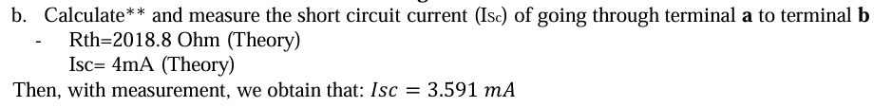

The function generator was connected to the oscilloscope and the digital multimeter (DMM). The function generator was set to output a sine wave with an amplitude of 5V. 2kΩ potentiometer was connected to the function generator. The potentiometer was adjusted until the voltage across it (VL) was approximately half the source voltage (Vth). The DMM was used to measure and record the voltage across the potentiometer (VL). This was found to be approximately 2.5V.

The function generator was disconnected from the circuit. The resistance between the two terminals that were connected to the function generator was measured using the DMM. This value was recorded as the Thevenin resistance (Rth), which was approximately 49Ω.

Vs= 5V, VL=2.4V, Rth= 49Ω